Graduation or Incarceration:
A Closer Look into MI School Discipline

Britney Tipler
Master of Public Policy
Michigan State University
Executive Summary

Racial and gender disparities in school discipline policy and practices have persisted for years. Although lawmakers have attempted to mitigate the use of punitive punishments by eliminating policies that have exacerbated disparities, no decision, law, or practice has substantially improved the disparities in discipline practices present in Michigan public schools. In 1990, the suspension rate for Black students in Michigan districts was 117 per 1000 students compared to 52 white students per 1000. Figure 1 displays the racial disparity gap only continued to increase exponentially following the passing of the Gun-Free Schools Act of 1993. This legislation was presented as a way to improve school safety and mitigate gun presence and gang violence in K-12 schools, but also served as the catalyst for further criminalization of young black and brown students nationwide. The effect of this federal legislation had a detrimental impact on schools in

Michigan that was reflected in data in the following years. In an effort to rectify the disparities within school discipline practices and policies, the U.S Department of Justice and U.S Department of Education issued discipline guidance package for states to follow. Shortly after, Michigan made strides towards eliminating disparities by abolishing to use of zero tolerance in schools in 2016. MI legislators also passed a Rethink Discipline bill package with hopes of improving the disparate treatment of children in MI K-12 schools. Unfortunately, after taking several steps forward, towards eliminating discriminatory practices in K-12 schools, in 2018, the Trump Administration abolished the federal guidance brought forth by the U.S Dept of Education and Dept. of Justice just years after its implementation. This brief outlines the implications and unintended consequences black and brown children continue to face as a result of the systemic problems within Michigan school discipline policies. I examine three public school districts throughout Michigan in order to observe the effects legislation has had on student learning and educational outcome

Figure 1. The number of out of school suspensions in Michigan Public School Districts in 1990 by racial demographic
School Discipline Policies Cause Black Students Harm
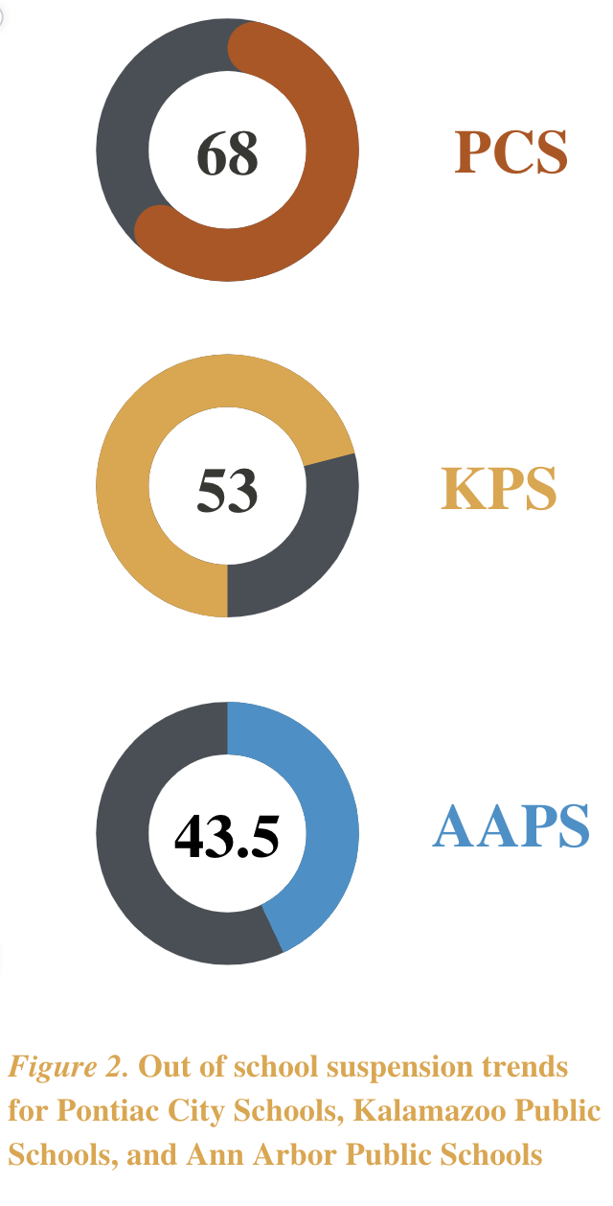
Historically, schools have issued punishments such as suspension or expulsion at much higher rates to the detriment of students of color, students with disabilities, or students experiencing trauma. Black students make up 15.5 percent of the U.S public school population, but 33.4 percent of the student arrests made in the 2013-2014 academic year were black students. In at least one study of the Grand Rapids School District, 31 percent of students with three or more suspensions before the spring semester of their sophomore year dropped out, while only 6 percent of students with no history of suspensions dropped out.Disparities in K-12 discipline practices result in many of our black and brown students being unable to attain high school degrees, good paying jobs, or even avoid being incarcerated. There is a correlation between the number of times students are suspended or expelled and their likelihood of ending up in the corrections system. The effects of exclusionary discipline have lifelong consequences for students of color in Michigan, with 68 percent of Michigan’s prisoners identified as high school dropouts.
This trend is known as the “school to prison pipeline”. The logic is that the intensive use of exclusionary forms of punishment will take a student off the path to graduation and success and place them on the pathway to prison. Our current disciplinary tactics are simply preparing students for prison life as we utilize actions that are a form of punishment rather than discipline that allows children to learn from their mistakes. Policy provisions have and continue to negatively impact Black students in Michigan Public schools. Figure 2. illustrates the disparities in school discipline practices in three public school districts, Pontiac City School District, Kalamazoo Public School District, and Ann Arbor Public School District. In 2009, Pontiac City Schools had the largest percentage of suspensions of black students in the country: for every 100 Black students, 68 were suspended at least once during the 2009-2010 school year. In Kalamazoo, black students accounted for 53 of the 73 school suspensions in the 2013-2014 academic year. Similarly, in Ann Arbor, 16.4 percent of the high school’s population was African American in 2015, but they accounted for 43.5 percent of the year's suspensions.Black and brown students continue to be villainized, incriminated and face harsher punishments within schools across the nation. The age at which we see this continuous pattern take place is becoming lower and lower every year. These statistics only emphasize the greater need for analysis to provide the insight that would help address systemic issues in K- 12 discipline policies and practices.

Disparities Persist Even After Zero Tolerance Era

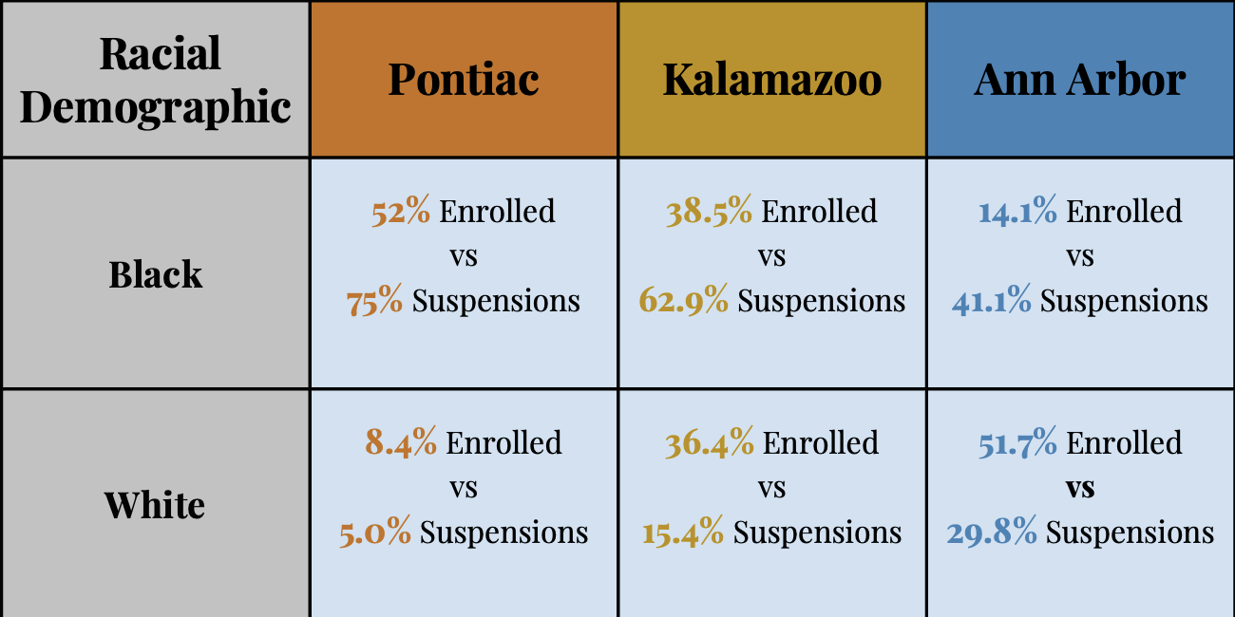
Although the number of out-of-school suspensions and expulsions have declined since the moratorium of zero-tolerance policy in schools, the disparities in discipline don’t seem to be vanishing. I collected 2017 school discipline reports from the Civil Rights Data Collection for Pontiac City Schools, Ann Arbor Public School District, and Kalamazoo Public School District. It was important for to examine schools that had a diverse racial demographic in order to see where the disparities persisted amongst various racial and ethnic groups. In Figure 3., we can see the disparities persist even after the elimination of zero tolerance policies. In Pontiac City Schools Black students take the lead for most out of school suspensions, in school suspensions, and expulsions. In 2017, Black students missed nearly 4000 days of school due to out of school suspensions that year. Although black students only made up 14 percent of Ann Arbor Public School District, they accounted for 41 percent of the out of school suspensions and 36 percent of the referrals to law enforcement. White students however make up about 52 percent of the district population and roughly 30 percent of the out of school suspensions. Similar trends are present within Kalamazoo Public Schools as Black students made up 69.7 percent of the in-school suspensions which was almost 3 times higher than that of other minorities. Black students also accounted for about 63 percent of out of school suspensions that contributed to over 6000 missed days of school for the entire school district.

Figure 3. The number of out of school suspensions versus the number of enrolled students in Michigan Public School Districts in 2017 by racial demographic

The disparities present within each of these school districts are very prevalent even after restorative justice bills and discipline guidance such as the MI Rethink Discipline bill package was implemented in Michigan schools. The data only confirmed that the removal of zero tolerance policies and implementation of restorative justice practices are simply not enough to eliminate the disparate treatment of black and brown students. Excessive use of exclusionary forms of punishment takes students off the path to graduation and success, and places them on the pathway to prison and other poor outcomes. When creating policy that will impact students, policy practitioners have a responsibility to ensure that children have access to safe, and equitable learning environments. If the policy threatens that goal, then reform needs to occur.

A Step in the Right Direction – Methods to Dismantle Disparities

To create more accurate, and equitable solutions, lawmakers must be transparent and acknowledge the shortcomings of discipline practices and policies that disproportionately harm Black students. I identify 3 key steps that Michigan can take in order to dismantle disparities in school discipline.

- Step 1: Reinstate the Joint School Disciple Guidance Package
Reinstating the federal discipline guidance is crucial to ensuring black children avoid experiencing discrimination or implicit bias in an environment meant to promote academic success. Research demonstrates that students who attend schools with high percentages of black students and students from low-income families are more likely to face security measures like metal detectors, random “contraband” sweeps, security guards, and security cameras, even when controlling for the level of misconduct in schools or violence in school neighborhoods (ACLU, 2017).
- Step 2: Implementing Trauma Informed Discipline Practices
Using a trauma informed approach to resolving conflicts and developing appropriate discipline responses would successfully support students and encourage them to maintain positive behavior within the classroom. Little attention has been paid to the fact that trauma is a contributing factor of classroom disruptions, outbursts, truancy, and long-term exposure to violence that causes severe emotional and behavioral difficulties (Baffour, 2016).

- Step 3: Annual Discipline Report
If we require districts to submit annual reviews of discipline policies and their implementation in schools, this can create a clearer picture of what might be allowing the disparities in school discipline practices to persist. Students of color are more likely to be subjected to more punitive and exclusionary forms of discipline when they are of a different race than their teacher. Research shows that people are more likely to exhibit behavior based on stereotyping and bias when their knowledge of others is ambiguous (Legal Defense Fund,2017).

The unfortunate reality is, school discipline policies in their current form do not make schools more conducive to learning, help improve student behavior, or make schools safer.
There is a difference between discipline and punishment and the practices being used in Michigan schools are a form of punishment which result in the exacerbated use of exclusionary forms of discipline based on their identities. Students of color can no longer be disenfranchised due to their race and gender. The disproportionate number of students affected by punitive punishments for menial offences only leads to one place, prison. In order to eliminate disparities in school discipline, Michigan must create equitable, policies that no longer disproportionately impact black and brown students.

Michigan State Advisory Committee, & Commission of Civil Rights. (1996, March). Discipline in Michigan Public Schools and Government Enforcement of Equal Education Opportunity.
Justin, Emily (2021) "Stopping the Flow: Eliminating the School-to-Prison Pipeline in Washington State," Seattle Journalfor Social Justice: Vol. 19: Iss. 2, Article 17.
Donahue, A. R. (2020, June 18). Police in schools 'prepare students for prison life,' advocates want change ⋆ Michigan advance. Michigan Advance.
ACLU of Michigan releases report identifying school-to-prison pipeline in State. ACLU of Michigan.
Slagter, L. (2017, March 27). Low-income, black students see more suspensions at Ann Arbor Schools. MiLive.
ACLU of Michigan releases report identifying school-to-prison pipeline in State. ACLU of Michigan.
Shah, N., & Maxwell, L. A. (2021, June 25). Researchers sound alarm over Black Student Suspensions. Education Week.
Green, C., Freidhoff, J., & Michigan Virtual. (2021, August 13). 4 ways that zero-tolerance policies affect Michigan students [with infographics]. Michigan Virtual.
Pontiac City Schools Discipline Report. Civil Rights Data Collection. (2017)
Ann Arbor Public Schools Discipline Report. Civil Rights Data Collection. (2017)
Kalamazoo Public Schools Discipline Report. Civil Rights Data Collection. (2017)

